REQUEST FOR TENDER (RFT)
Bankable Nature Solutions (BNS) potential private sectors/ entities (project owner) and project pipeline mapping

Concept Note
02.29.2024

Prepared by:
Sustainable Finance Team, WWF-Indonesia

Brief  Description | This proposed concept note is built based on WWF Indonesia needs to seek relevant consultant to carry out baseline mapping supporting Bankable nature solutions (BNS) related work development.

- Rationale

Collapsing ecosystems is a phenomenon we are increasingly facing, calling for new solutions. Biodiversity loss and climate change pose tremendous challenges to our planet and its people. The Living Planet Report (2018) found a decline of 60% in population sizes of vertebrate species in the period 1970- 2014. The tropics of Latin America even faced an 89% loss in the same period. Hundreds of millions of people are already exposed to the effects of biodiversity loss and climate change.

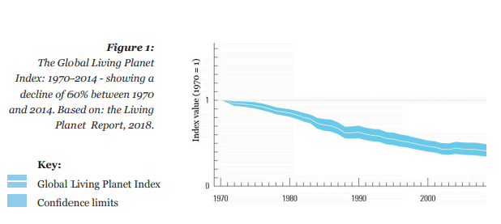

Restoring nature can help people to adapt by providing an ongoing source of food and other ecosystem services that support livelihoods, whilst also providing protection against extreme weather events. There is a quest for bankable projects which could create positive environmental returns that lead to improved biodiversity and climate mitigation and/or adaptation, while also being attractive for financial institutions to invest in. WWF refers to these bankable projects as Bankable Nature Solutions.

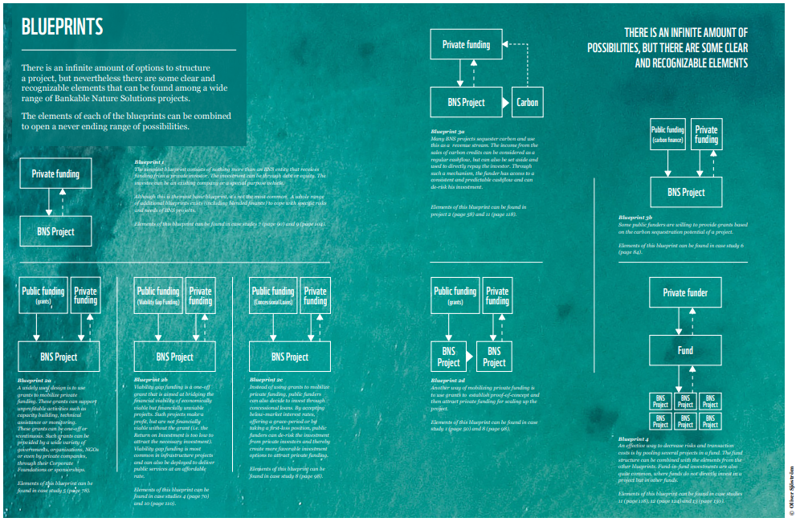

According to the WWF South Pole study, there are four elements of successful factors in delivering bankable nature-solutions projects (BNS). They are:

- Technical set up and design: including project partner(s) selection, design of the technical intervention (including location and scale), selection of beneficiaries and analysis/review of the regulatory framework, among others.

- Feasibility and piloting: any activities related to demonstrating the feasibility and bankability of the technical concept developed under Phase 1. This can include conducting a feasibility study, demonstrating the business case, piloting the concept and securing anchor funders/investors.

- Investment structuring: all activities related to structuring and disbursing investments and implementing the project activities.

- Revenues and impact generation: all activities related to generating financial returns (e.g. plantation, conservation or restoration activities generating carbon credits and production activities for projects relying on the sales of sustainable commodities, among others) and environmental and social impacts.

In addition – the report classifies essential factors that make a project successful. Certain key essentials such as:

- Project owner/ private sectors’ expertise, track record and capabilities in which how the project owner’s expertise/ track record helped improve the bankability of the project.

- Business case/ economic analysis of the intervention, how the project can demonstrate a business case for investments by providing a robust economic analysis of the value it would deliver to investors. While developing a business case is always essential to the bankability of a project, this success factor was analyzed specifically in cases that involved valuing ecosystem services which are not typically translated into economic terms.
  - Essential: Low frequency due to the specific focus of the analysis on the economic valuation of payments for ecosystem services, but a strong business case is an essential requirement for private investors.

- Offtake agreement, the project secured offtake agreements for one or several of its outputs (e.g. carbon credit offtake and sustainable commodities offtake), providing demand security over a set period of time.
  - Essential: Securing a market for the project’s products, including via offtake agreements, is essential to ensure stable and sufficient revenues. However, the way this is achieved can vary widely depending on the products considered.

- Securing a market, the project secured a market for its products (e.g. sustainable commodities) by taking additional, specific steps to identify and secure buyers. This can include marketing activities targeting specific audiences for the product developed. This differs from offtake agreements insofar as it happens after the output has been produced and is not negotiated ahead of time.

  - Essential: Securing a market for the project’s products, including via offtake agreements, is essential to ensure stable and sufficient revenues. However, the way this is achieved can vary widely depending on the products considered.

- Objective

This proposed concept note is built based on WWF Indonesia needs to seek relevant consultant to carry out baseline private sectors related on certain commodities supply chains vulnerable to key sustainability issues that are eligible to be scaled as a Bankable nature solutions (BNS) projects pipeline.

- Scope

To contribute to the said key targets (climate and nature), WWF-Indonesia is prioritizing key landscapes and seascapes in East Kalimantan and Coral Triangle to be targeted in enhancing the conservation gains in which mobilizing finance towards the BNS projects is one of the approach, WWF-Indonesia is seeking a consultant to cover activities that deliver several key baseline outputs such as:

- To identify potential BNS eligible private sectors (as a project owner) to target, its value chains and its project pipeline potentials in key sectors that are considered vulnerable with climate issues (coffee and to select one of the most economically and climate vulnerable non-timber forest product) in Aceh.
  - preferably linked to sustainable value chains. Completed with information on the supply chain actors (traders, exporters importers, FMCG companies, retailers)
  - to include companies registered in the relevant certification scheme for the selected commodities (to refer the recognized under the ISEAL certification)
  - Private sectors (producer, processor, trader, exporters or importers (classifications from medium, large, and/or listed companies) that are deemed eligible to be targeted as the project owner of the BNS approach.
  - The products origin is coming from Aceh (preferably withing the Peusangan, Jambo Aye, Tamiang (PJT).

- To identify current business model of each companies/ private sectors mapped, current revenues and planned revenues, capex and opex needs.

- To identify vulnerabilities and resilience assessment using relevant methods

- To identify private sectors/ companies’ sustainability commitments or their sustainability target/ roadmap, completed with willingness to adopt BNS approach assessment.

- To identify the private sectors’ expertise, track record and capabilities to carry out BNS business model.

Methods:

- The consultant is expected to demonstrate the most suitable methodology based on their experience and expertise. In addition to demonstrate a robust and proven reference of its proposed methodology.
- The approach will cover both desktop research, focus group discussion, bilateral interviews, and field visits.
- The consultant will deliver an inception report of approach, strategy and planning on how to achieve the project outputs completed with a sprint (progress timeline and achievement in a google docs regularly)
- To leverage several relevant WWF’s references in carrying out the exercise

Target output

- This output will be delivered in an excel database, a narrative report as well as a slide deck.
- Provide report and analysis related to the identified the relevant profile of the private sectors’ that is needed to be used as potential BNS projects developments key modality.
- Inception report to outline the workplan and target output of each timeline.

Consultant’s requirements

Expertise and Experience

- The entity must have a demonstrated track record and proof concept/ successful delivery of conducting relevant bankable-nature solutions like mapping projects and develop innovative business model linked to business, environmental& social impact and returns.
- Experience in working with local stakeholders, commodities related, SMEs and large companies, financial institutions, government agencies, and environmental organizations is highly desirable.
- The entity should have a multidisciplinary team comprising commodities and market specialists, environmental scientists, economists, and finance experts.

Technical Capacity

- Demonstrate its understanding and ability to identify relevant bankable nature-solutions projects.
- Demonstrate its ability to deliver tasks in an efficient and effective manner.
- Demonstrate its ability to provide key challenges and issues completed with the proposed solution to fulfill gaps (for instance limited datasets)
- Understanding of financial instruments and mechanisms for financing nature-based solutions projects.
- Capability to assess the financial viability and potential returns on investment of nature-based solutions.
- Experience in structuring and implementing bankable projects in collaboration with financial institutions and investors.

Stakeholder Engagement

- Ability to engage with diverse stakeholders including government agencies, local communities, NGOs, and private sector entities.
- Experience in facilitating participatory decision-making processes and fostering collaboration among stakeholders.
- Strong communication and negotiation skills to build consensus and mobilize support for nature solutions initiatives.

Regulatory Compliance

- Knowledge of relevant environmental regulations, policies, and international conventions related to nature conservation and sustainable development.
- Compliance with legal requirements for data collection, analysis, and reporting, including privacy and data protection regulations.

Project Management

- Proficiency in project management methodologies to ensure timely delivery, budget adherence, and quality control.
- Ability to develop comprehensive project plans, monitor progress, and mitigate risks throughout the project lifecycle.
- Experience in mobilizing resources, managing partnerships, and coordinating activities across multiple stakeholders.
- Commitment to ethical standards, transparency, and integrity in all aspects of project implementation.
- Adherence to professional standards and codes of conduct, such as those established by relevant professional organizations or industry associations.

Reporting and Documentation

- Capability to generate clear, concise, and scientifically robust reports and documentation for various stakeholders.
- Provision of robust analysis based on task results to inform decision-making.

Financial Proposal

- Submission of a detailed financial proposal outlining the cost structure, budget allocation, and payment schedule for each task.
- Transparent breakdown of expenses including personnel costs, equipment and software licenses, travel and fieldwork expenses, and overheads.

Project duration

The project will be kicked off from April to Mid-June 2024 (the latest).

Budget

IDR 325.000.000,-

Annex.

See following link for full reference: https://wwfint.awsassets.panda.org/downloads/bankable_nature_solutions_2__1.pdf

Blueprint 1
The simplest blueprint consists of nothing more than an BNS entity that receives funding from a private investor. The investment can be through debt or equity. The investee can be an existing company or a special purpose vehicle. Although this is the most basic blueprint, it’s not the most common. A whole range of additional blueprints exists (including blended finance) to cope with specific risks and needs of BNS projects. Elements of this blueprint can be found in case studes 7 (page 90) and 9 (page 104).

Blueprint 2a
A widely used design is to use grants to mobilize private funding. These grants can support unprofitable activities such as capacity building, technical assistance or monitoring. These grants can be one-off or continuous. Such grants can be provided by a wide variety of governments, organizations, NGOs or even by private companies, through their Corporate Foundations or sponsorships.

Blueprint 2b
Viability gap funding is a one-off grant that is aimed at bridging the financial viability of economically viable but financially unviable projects. Such projects make a profit, but are not financially viable without the grant (i.e. the Return on Investment is too low to attract the necessary investment). Viability gap funding is most common in infrastructure projects and can also be deployed to deliver public services at an affordable rate.

Blueprint 2c
Instead of using grants to mobilize private funding, public funders can also decide to invest through concessional loans. By accepting below-market interest rates, offering a grace-period or by taking a first-loss position, public funders can de-risk the investment from private investors and thereby create more favorable investment options to attract private funding. Elements of this blueprint can be found in case study 8 (page 98).
Blueprint 2d
Another way of mobilizing private funding is to use grants to establish proof-of-concept and then attract private funding for scaling up the project. Elements of this blueprint can be found in case study 1 (page 50) and 8 (page 98).

Blueprint 3a
Many BNS projects sequester carbon and use this as a revenue stream. The income from the sales of carbon credits can be considered as a regular cashflow, but can also be set aside and used to directly repay the investor. Through such a mechanism, the funder has access to a consistent and predictable cashflow and can de-risk his investment. Elements of this blueprint can be found in project 2 (page 58) and 11 (page 118).

Blueprint 3b
Some public funders are willing to provide grants based on the carbon sequestration potential of a project. Elements of this blueprint can be found in case study 6 (page 84).
Blueprint 4
An effective way to decrease risks and transaction costs is by pooling several projects in a fund. The fund structure can be combined with the elements from the other blueprints. Fund-in-fund investments are also quite common, where funds do not directly invest in a project but in other funds. Elements of this blueprint can be found in case studies 11 (page 118), 12 (page 124) and 13 (page 130)

